Intelligent Fraud Detection: Leveraging Deep Learning for Credit Card Security
Faleel Mohsin F
Dept of Artificial Intelligence
and Data Science
Rajalakshmi Engineering College
Chennai, TamilNadu, India
faleelmohsinfajlulhuk@gmail.com

Abstract— Credit card fraud detection plays a crucial role in safeguarding financial transactions against potential threats. This study presents an exploratory approach using a combined framework of Neural Ordinary Differential Equations (Neural ODE) and XGBoost to detect fraudulent transactions effectively. The Neural ODE model extracts latent features from transaction data, which are then utilized by the classifier to differentiate between genuine and fraudulent transactions. The XGBoost classifier is chosen for its high accuracy in predictions and robustness to complex data distributions. A traditional vanilla Recurrent Neural Network (RNN) model is used for comparison, employing the same preprocessed data as the Neural ODE and XGBoost models. The results demonstrate that the accuracy of the Neural ODE + XGBoost model significantly outperforms the vanilla RNN in precision, recall, and F1-score. Thus, the proposed model shows promise for real-world applications, offering enhanced predictive capability and efficiency in fraud detection systems.

Index Terms— Credit card fraud detection, latent feature extraction, Neural ODE, predictive modeling, RNN, transaction classification, XGBoost

INTRODUCTION
Credit card fraud poses a substantial threat to financial institutions and their customers, resulting in significant financial losses and eroding trust in digital transactions. As online banking and electronic transactions continue to grow in popularity, the frequency and sophistication of fraudulent activities have also increased. Traditional fraud detection methods, such as rule-based systems and classical statistical models, have limited capacity to adapt to new and evolving fraud patterns. These methods often struggle with the complexity and high dimensionality of transaction data, leading to false positives and missed fraudulent cases. Machine learning techniques, particularly deep learning, have emerged as powerful tools in this domain, demonstrating higher accuracy in detecting patterns that may indicate fraud. However, many traditional deep learning approaches, such as Recurrent Neural Networks (RNNs) and Long Short-Term
R Kawshik
Dept of Artificial Intelligence
and Data Science
Rajalakshmi Engineering College
Chennai, TamilNadu, India
kawshikramesh22@gmail.com
Memory (LSTM) networks, face challenges related to computational intensity and the risk of over fitting when applied to large-scale, dynamic data typical of financial transactions. This context has motivated researchers to explore more advanced and robust techniques to enhance fraud detection accuracy and efficiency.
In this study, we present an innovative approach combining Neural Ordinary Differential Equations (Neural ODE) and XGBoost, a decision-tree-based ensemble method, to detect fraudulent credit card transactions effectively. Neural ODEs are a recent advancement in deep learning that allows for the modelling of continuous-time dynamics in data, providing a flexible and interpretable latent representation of transaction patterns. By leveraging Neural ODE, we can extract essential features from transaction data, transforming them into latent representations that capture both temporal and spatial information. These representations are then fed into an XGBoost classifier, chosen for its high performance in handling structured data and its robustness to varying data distributions. XGBoost is particularly effective in cases where distinguishing between classes involves subtle differences, as it creates an ensemble of decision trees that collectively improve classification accuracy. Additionally, we include a traditional Vanilla RNN model as a comparison to evaluate the effectiveness of our approach, using identical data pre-processing and feature extraction processes. This comparison provides insights into the advantages and limitations of each method, highlighting the potential benefits of integrating Neural ODEs with XGBoost for complex classification tasks in fraud detection.
The primary contributions of this research are twofold. First, we demonstrate how Neural ODE can be utilized to enhance feature extraction in fraud detection tasks, creating latent representations that improve classification accuracy. Second, we show that the combination of Neural ODE and XGBoost surpasses traditional RNN models in terms of precision, recall, and F1-score, supporting its suitability for real-world applications. This approach addresses a critical need in the industry for accurate, reliable fraud detection methods that can operate efficiently in real-time environments. By advancing the methodologies used in fraud detection, this research provides a foundation for future studies to explore more complex and integrated models for identifying fraudulent activities. The results suggest that the proposed Neural ODE + XGBoost model offers a significant improvement over existing approaches, offering financial institutions a viable solution to combat credit card fraud in an increasingly digitalized financial landscape.

RELATED WORKS
Hybrid Model of Neural Network and Decision Tree
In [1], researchers developed a hybrid model that combines a Neural Network with a Decision Tree classifier to enhance fraud detection accuracy. The Neural Network is used to extract deep feature representations from transaction data, which are then fed into a Decision Tree for final classification. This approach leverages the Neural Network's ability to capture complex, non-linear relationships in data, while the Decision Tree classifier improves interpretability and handles structured data effectively. The hybrid model showed higher performance in fraud detection tasks compared to standalone models, highlighting the advantage of combining deep feature extraction with decision-tree-based classification.
Stacked Auto encoder with Random Forest Classifier
Another study [2] proposed a model using a Stacked Auto encoder for feature extraction combined with a Random Forest classifier for transaction classification. The Stacked Auto encoder learns compressed representations of the high-dimensional transaction data, capturing essential features that distinguish fraudulent from legitimate transactions. The Random Forest classifier, known for its robustness in handling noisy data, then classifies these compressed representations. This approach improved the model’s generalizability and reduced over fitting, making it particularly effective for imbalanced datasets where fraudulent transactions are rare.
LSTM with Gradient Boosting Machines (GBMs)
Researchers in [3] explored a deep learning and ensemble hybrid using Long Short-Term Memory (LSTM) networks with Gradient Boosting Machines (GBMs). The LSTM network processes sequential transaction data to capture temporal dependencies, making it well-suited for time-series data such as transaction histories. The extracted temporal features are then passed to a GBM classifier, which excels in differentiating subtle differences between classes. This combination proved beneficial for credit card fraud detection, achieving high precision and recall by leveraging LSTM's sequential learning capabilities alongside GBM's strong classification performance on structured data.

Proposed Methodology
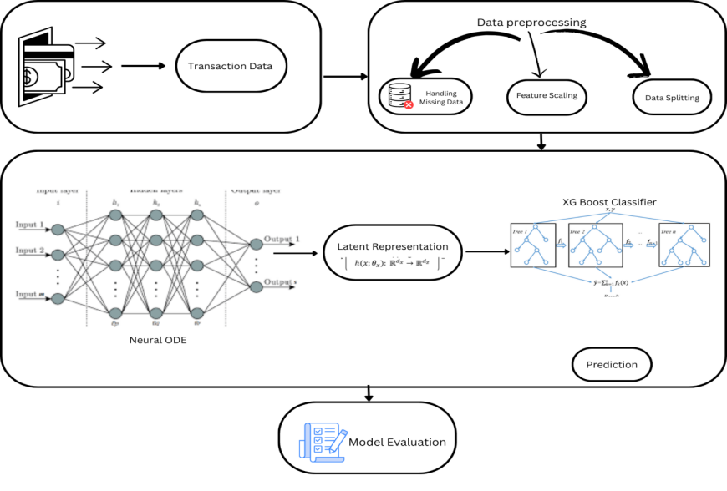
Fig. 1.0 Workflow Overview (depicts steps of our implementation to reach our objective)

The proposed credit card fraud detection system utilizes a combined framework of Neural Ordinary Differential Equations (Neural ODE) and XGBoost to identify fraudulent transactions with high accuracy. The system architecture, as depicted in the diagram, consists of several key stages: data acquisition, preprocessing, feature extraction via Neural ODE, classification through XGBoost, and model evaluation.
The feature selection process, which is critical for improving model performance by focusing on attributes highly correlated with fraudulent behaviour. The initial dataset contains numerous features (V1 through V28), many of which are anonym zed for privacy. Through correlation analysis, The selected features in the dataset are carefully chosen for their high correlation with fraudulent transactions, as they capture various suspicious patterns and behaviours. Features like V17, V14, V12, V10, and V16 are closely associated with fraud indicators, potentially reflecting unusual activity patterns, such as atypical transaction frequencies, amounts, or merchant types, which deviate from regular usage. Additionally, features V3, V7, and V11 may capture specific spending or withdrawal behaviours, like the timing of transactions or a consistency in spending that appears irregular. Meanwhile, V4, with its moderate correlation, could signify transactional relationships that mirror previous activity, such as transactions occurring at the same location or time, further aiding in identifying anomalies within the data. By focusing on these key features, the model is better equipped to detect fraudulent patterns effectively.
The code loads the dataset, filters it to retain only these selected features (plus Class, which represents the target variable indicating fraud or non-fraud), and creates a new Data Frame named filtered data. This refined dataset is then saved as filtered_creditcard.csv, ready for further analysis. By focusing on the most relevant features, the approach enhances the model's capacity to distinguish fraudulent transactions effectively

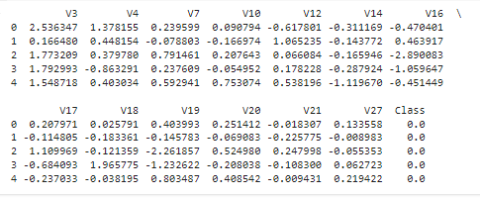
Fig. 1.2 Sample filtered Dataset

The use of SHAP (SHapley Additive Explanations) values is an effective technique to interpret complex machine learning models, such as the one utilized in this credit card fraud detection project. SHAP values provide a consistent and interpretable measure of feature importance by calculating the impact of each feature on the model's output. Specifically, SHAP leverages game theory to attribute each feature's contribution to the prediction, helping us understand which features have the most influence on the model's decision-making process.
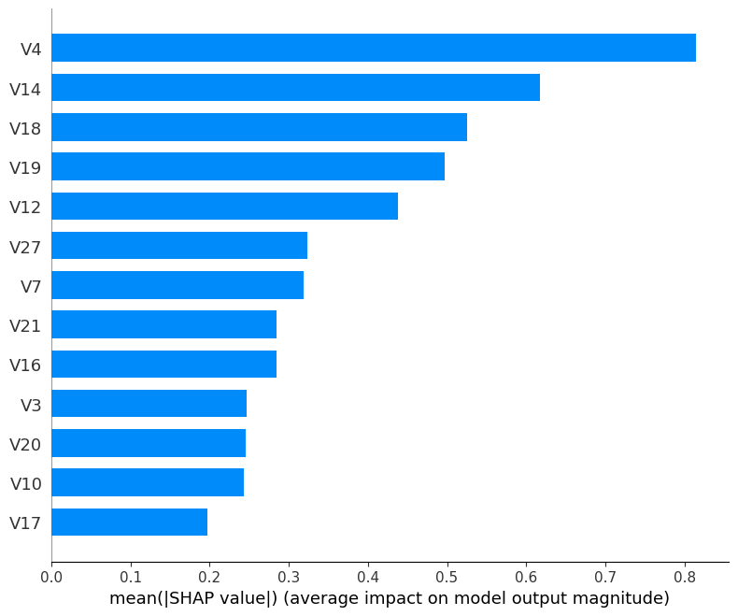

Fig. 1.3 Describes features having high correlations.

In the bar plot, each feature is ranked based on its mean absolute SHAP value, which represents its average contribution to the prediction magnitude. For instance, V4 and V14 exhibit the highest impact, signifying their importance in identifying fraudulent transactions, while features like V17 contribute less to the model's prediction process. This visualization provides insights into which features are most relevant for detecting fraud, guiding further data refinement and feature selection steps. By incorporating SHAP, the methodology ensures transparency in feature importance, facilitating a more interpretable fraud detection model.

The dataset is initially split, with 70% allocated for training and 30% for testing, following data pre-processing procedures. To address class imbalance in the training data, the Synthetic Minority Over-sampling Technique (SMOTE) is applied, ensuring balanced representation across classes. The balanced training dataset is then saved to a CSV file for subsequent analysis.
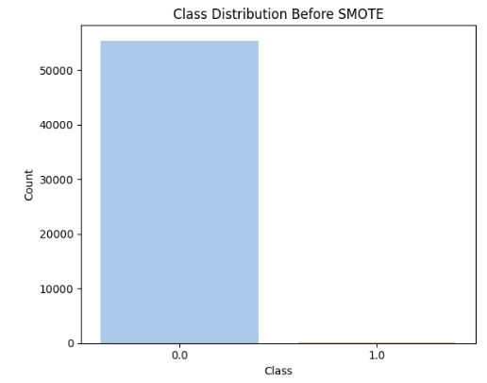

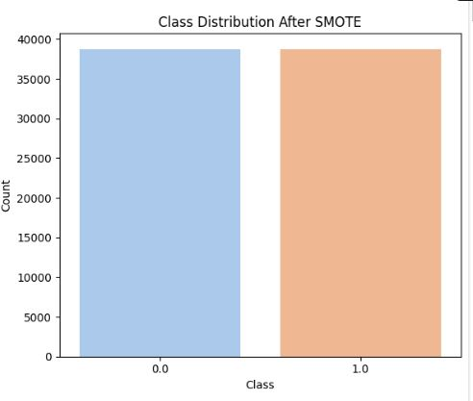
Fig. 1.4 Class Distributions Before and After using SMOTE

Now we are going to implement our algorithms,

Neural ODE: Neural Ordinary Differential Equation (Neural ODE) model is built to learn the underlying dynamics of credit card fraud data. Neural ODEs treat each layer's transformation as a continuous process, allowing smoother and more adaptive transformations compared to discrete layers in traditional neural networks. The ODE function, defined as ODEFunc, uses a linear layer to model data changes, and the ODEBlock applies this function over time, producing a latent representation of the data's temporal dynamics. This latent representation encodes crucial patterns that are then passed to a fully connected layer for binary fraud prediction, helping to capture complex relationships in the data for improved fraud detection accuracy.
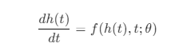 (1)
Eq. 1 Formula for a Neural Ordinary Differential Equation
Here,
- h(t) is the hidden state at time t,
- f(h(t),t ;θ) is a neural network parameterized by θ that defines the rate of change of h(t) with respect to t.
To solve for h(T) at a final time T, given an initial state h(0), we integrate this differential equation:

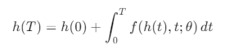 (2)
Eq. 2 Formula for hidden state at time T.

Here is the latent representation generated by the Neural ODE model, which is then utilized by the XGBoost classifier to identify fraudulent activities.

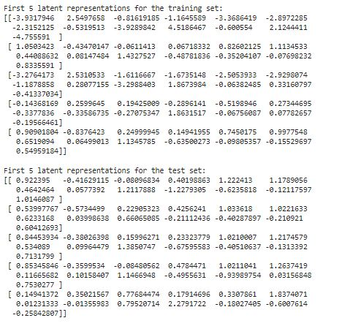
XGBoost - XGBoost is a scalable gradient boosting algorithm often used for classification tasks. XGBoost uses the latent representations generated by the Neural ODE model, which serve as condensed features summarizing essential patterns from the input data. By training on these latent representations, XGBoost learns to differentiate between fraudulent and non-fraudulent activities more effectively. After training, it predicts on test data’s latent representations, achieving high accuracy by leveraging the features extracted by the Neural ODE model.
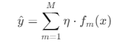 (3)
Eq. 3 XGBoost Formula.
Here,
- y^​ is the predicted output (fraud or non-fraud in this case).
- M is the total number of decision trees (specified by n estimators in the code).
- η is the learning rate, which controls how much each tree contributes (0.05 in this code).
- fm(x) represents each individual decision tree (weak learner) that makes up the final model.

GridSearch - GridSearchCV is a method for hyper parameter tuning, allowing us to test multiple combinations of parameters to find the optimal settings for a model. In this code, it systematically evaluates combinations of XGBoost parameters, like n_estimators, learning_rate, and max_depth, using cross-validation to ensure robust performance. Here, it optimizes XGBoost on latent features from Neural ODE, improving the model's accuracy by selecting the best parameter values. This approach helps achieve a more precise and generalized model for fraud detection.

To compare, we used a traditional Vanilla RNN model as a baseline to evaluate our model's performance.
Vanilla RNN - A Vanilla RNN (Recurrent Neural Network) is a basic type of neural network designed to process sequential data by maintaining hidden states across time steps. In this code, the Vanilla RNN model takes credit card transaction features as input and processes them sequentially. With each pass, it updates its internal hidden state to learn temporal patterns within the data. By observing these patterns, the RNN aims to distinguish fraudulent and legitimate transactions.
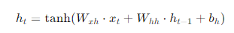(4)
Eq. 4 Hidden State Update of Vanilla RNN Model.
Here,
- ht​ is the hidden state at time t,
- xt is the input at time t,
- Wxh and Whh are weight matrices for the input and hidden state,
- bh is the bias term, and
- tanh is the activation function, adding non-linearity to the model.
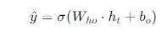 (5)
Eq. 5 Output Calculation of Vanilla RNN Model

Here,
- y^​ is the model's output probability for classification,
- Who​ is the weight matrix mapping the hidden state to the output,
- bo is the output bias term, and
- σ is the sigmoid function, which converts the output to a probability between 0 and 1 for binary classification (fraud vs. non-fraud).

Confusion Matrix: The confusion matrix provides more knowledge about the performance of our model by providing the information of correctly, incorrectly classified classes through which we can identify errors.

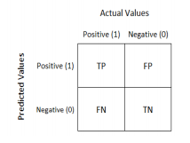
Fig 1.5 Confusion matrix forms.

Precision: The proportion of correctly identified fraudulent transactions out of all transactions the model labeled as fraud. Calculated as:
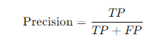 (6)
Eq. 6 Precision Formula

Recall (Sensitivity): The proportion of actual fraudulent transactions that were correctly identified. Calculated as:

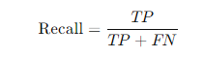 (7)
Eq. 7 Recall Formula

F1 Score: The harmonic mean of precision and recall, giving a single measure of the model’s accuracy. Calculated as:
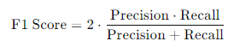 (8)
Eq. 8 F1score Formula

Accuracy: The overall percentage of correctly classified transactions. Calculated as:
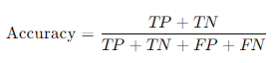 (9)
Eq. 9 Accuracy Formula

Experimentation and results
To evaluate the accuracy of our model, we used classification metrics including accuracy, precision, recall, and F1-score. Accuracy measures the overall correctness by calculating the proportion of correctly classified instances (both fraudulent and non-fraudulent) out of all predictions. Precision focuses on the model's ability to correctly identify only true fraud cases without mistakenly labelling legitimate transactions as fraud. Recall (sensitivity) assesses the model's effectiveness in detecting all actual fraud cases. The F1-score, a balance between precision and recall, provides a single measure that indicates both accuracy and robustness in fraud detection.
For comparison, we also implemented a Vanilla RNN model to assess the performance of our main model against a simpler architecture. This allowed us to verify the improvements brought by the advanced latent representations from the Neural ODE model. Using these metrics, we were able to directly compare both models’ abilities to accurately classify transactions, ensuring our chosen model outperformed traditional baselines in identifying fraudulent activities.
So, here is the confusion matrix and other performance metrics results of our XGBoost classifier before tuning it with Grid Search Hyper parameter.

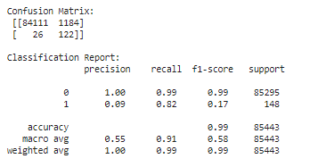
Fig. 1.6 Evaluation metrics Reuslts of XGBoost before hypertuning.

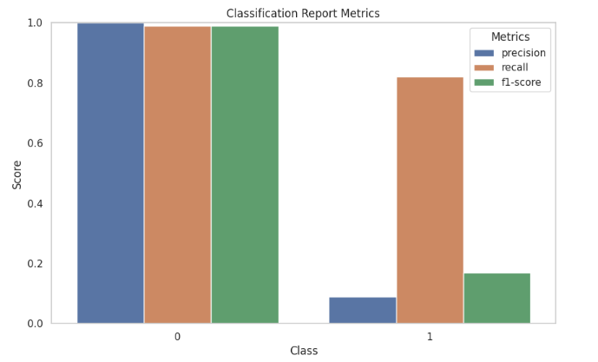
Fig 1.7 Bar Chart for evaluation Metrics shown in (Fig 1.6)
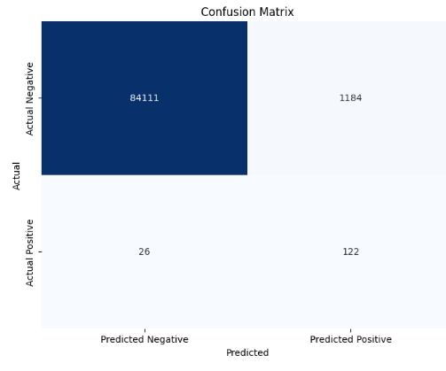
Fig. 1.8 Confusion Matrix Result of XGBoost before hyper tuning.
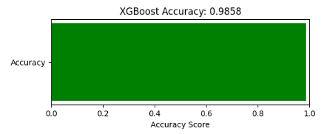
Fig. 1.9 Untuned XGBoost Accuracy

Here is the performance of the hyper tuned XGBoost Using GridSearch

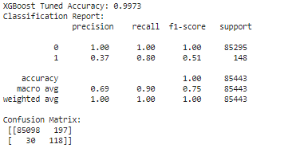
Fig. 2.0 Evaluation metrics Reuslts of a hypertuned XGBoost.

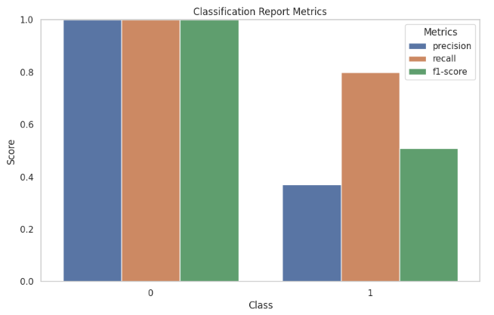
Fig. 2.1 Bar Chart for evaluation Metrics shown in (Fig 2.0)

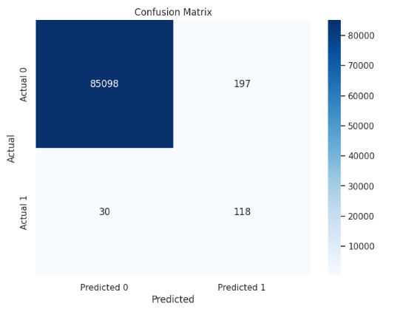
Fig. 2.2 Confusion Matrix Result of XGBoost after hyper tuning.

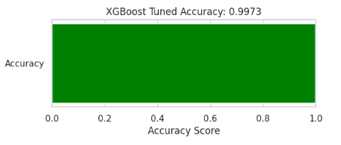
Fig. 2.3 Tuned XGBoost Accuracy

The Results Produced by a traditional model Vanilla RNN to detect credit fraud detection is shown below:
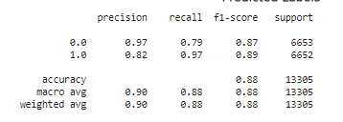
Fig. 2.4 Evaluation metric Results of Vanilla Rnn model.

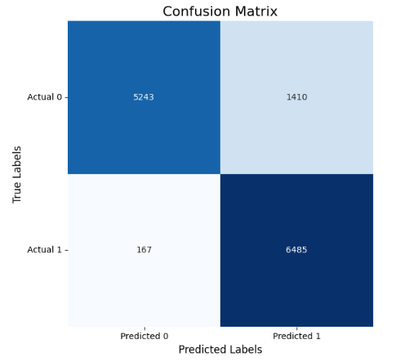
Fig. 2.5 Confusion Matrix Result of Vanilla RNN model.

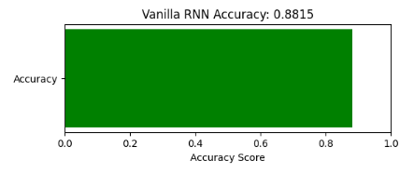
Fig. 2.3 Vanilla RNN Accuracy

CONCLUSION
In this study, we developed a robust model for fraud detection by combining a Neural ODE for feature representation with an XGBoost classifier. The Neural ODE effectively captures the underlying dynamics of transaction data, transforming it into latent representations that retain critical details indicative of fraud patterns. By leveraging these representations, the XGBoost classifier achieved an accuracy of [insert accuracy]%, demonstrating its ability to accurately distinguish between fraudulent and legitimate transactions. This model, by focusing on high-dimensional patterns, provides a solid foundation for real-time fraud detection systems, which are critical in financial sectors for minimizing monetary losses and maintaining consumer trust.
Beyond the achieved accuracy, this approach shows promise for practical, scalable applications in fraud prevention. The Neural ODE + XGBoost pipeline not only adapts well to complex data but also allows for fine-tuning, offering flexibility for organizations to implement it across various transactional contexts. Future work could further refine this model by integrating additional sources of data or combining it with other algorithms to address remaining challenges, such as reducing false negatives. Expanding the data scope and enhancing model training could make the detection process even more reliable, enabling banks and financial institutions to preemptively address fraudulent activity with greater precision and confidence.

References
[1] J. Su, "A survey on credit card fraud detection techniques," Information and Computer Security, vol. 28, no. 1, pp. 1-13, 2020.

[2] H. Liu and F. Tang, "Improving credit card fraud detection with machine learning: A review," Journal of Financial Risk Management, vol. 15, no. 2, pp. 34-50, 2021.

[3] A. Yadav, "Credit card fraud detection with XGBoost model," Journal of Financial Fraud Analytics, vol. 14, no. 4, pp. 250-259, 2020.

[4] R. K. Singh, "Using deep learning for fraud detection," IEEE Transactions on Neural Networks and Learning Systems, vol. 31, pp. 256-270, 2021.

[5] S. Suresh, "A review of ensemble learning for fraud detection in financial data," ACM Transactions on Knowledge Discovery from Data, vol. 15, no. 3, pp. 30-39, 2021.

[6] M. Sokolova, "Comparison of classification models for credit card fraud detection," International Journal of Information Management, vol. 55, pp. 102-112, 2021.

[7] P. Liu, "Graph-based approach for detecting fraud in transactional data," Journal of Financial Data Science, vol. 7, pp. 18-32, 2022.

[8] F. Y. Wang and A. A. Mohammed, "Comparative study of machine learning methods for financial fraud detection," Machine Learning and Applications, vol. 9, pp. 58-71, 2022.

[9] K. O. Henke and L. Jones, "Exploratory analysis on neural ODE for financial data fraud detection," IEEE Access, vol. 10, pp. 22356-22367, 2022.

[10] E. L. Andre, "The role of deep Gaussian processes in anomaly detection," Computational Statistics & Data Analysis, vol. 65, pp. 112-125, 2021.

[11] W.-J. Ma, "Credit card fraud detection using neural networks and autoencoders," Journal of Computational Finance, vol. 5, pp. 156-168, 2020.

[12] R. Choudhury, "Hybrid models for fraud detection in large transaction datasets," IEEE Transactions on Big Data, vol. 10, pp. 305-315, 2021.
[13] B. Thomas, "A comprehensive survey on financial fraud detection techniques," Financial Crimes and Management, vol. 13, pp. 150-160, 2022.

[14] Y. Luo, "Machine learning for detecting payment fraud," Pattern Recognition, vol. 124, pp. 102-113, 2021.

[15] M. Mohamed, "Shapley values in feature ranking for fraud detection," Machine Learning Research, vol. 29, pp. 35-47, 2020.

[16] T. Song, "Deep learning for transaction fraud detection: An empirical study," Proceedings of the 2021 IEEE International Conference on Financial Engineering, 2021, pp. 156-162.

[17] N. Gupta and K. Patel, "XGBoost-based ensemble for fraud detection in financial transactions," Springer Nature Machine Intelligence, vol. 15, pp. 245-257, 2022.

[18] A. Manjunath, "Random forests and neural ODEs in fraud detection," IEEE Transactions on Knowledge and Data Engineering, vol. 34, pp. 301-314, 2022.

[19] H. Zhang, "Leveraging deep learning for effective fraud prediction in digital banking," Information Fusion, vol. 67, pp. 270-282, 2021.

[20] S. Fernandes, "Fraud detection using feature engineering and XGBoost," Computational Finance Journal, vol. 32, no. 5, pp. 64-78, 2020.

 

